Assignment 6: Medians, Order Statistics, and Elementary Data Structures
Ranjith Kumar Bollam
University of the Cumberlands
MSCS 532 – Algorithms and Data Structures
April 05, 2026

Introduction
Efficient data processing is a core requirement in computer science, especially when dealing with large datasets. Two fundamental areas that contribute to this efficiency are order statistics and data structures. Order statistics focus on identifying specific elements within a dataset, such as the median or the k-th smallest element, while data structures determine how data is stored, accessed, and manipulated. This assignment explores both areas by implementing selection algorithms and elementary data structures. The goal is not only to understand their theoretical behavior but also to evaluate their performance through practical experimentation. By combining implementation, analysis, and empirical testing, this work provides a comprehensive understanding of how these concepts operate in real-world scenarios.
Part 1: Selection Algorithms
Implementation Overview
Two different selection algorithms were implemented to determine the k-th smallest element in an array: Randomized Quickselect and the Deterministic Median of Medians algorithm. The Randomized Quickselect algorithm works by selecting a pivot randomly from the input array and partitioning the elements into three groups: those less than the pivot, equal to the pivot, and greater than the pivot. Based on the size of these groups, the algorithm recursively processes only the relevant portion of the array. This reduces unnecessary comparisons and leads to efficient performance in most cases.
In contrast, the Deterministic Median of Medians algorithm ensures a balanced partition by dividing the array into smaller groups of five elements. The median of each group is calculated, and then a recursive process determines the median of these medians. This value is used as a pivot, guaranteeing that the partition is sufficiently balanced at every step.
Both implementations were designed to handle duplicate values and varying input sizes effectively.
Time Complexity Analysis
The time complexity of these algorithms highlights the trade-off between guaranteed performance and practical efficiency.
The Randomized Quickselect algorithm has an average-case time complexity of O(n), making it efficient for most practical applications. This efficiency arises because, on average, the randomly chosen pivot divides the array into reasonably balanced sections. However, in the worst case, when poor pivot choices occur repeatedly, the time complexity can degrade to $O(n^{2})$. Although this worst-case scenario is unlikely, it remains a theoretical limitation.
On the other hand, the Deterministic Median of Medians algorithm guarantees a worst-case time complexity of $O(n)$. This is achieved by carefully selecting pivots, ensuring each partition removes a significant portion of the array. However, the additional computations required to determine the median of medians introduce overhead, making this approach slower in practice.
In terms of space complexity, both algorithms require additional memory for recursive calls and intermediate arrays. While this overhead is manageable, it is still an important consideration when working with very large datasets. This difference highlights the trade-off between theoretical guarantees and practical efficiency, where algorithms with stronger guarantees may not always perform better in real-world scenarios due to additional overhead.
Empirical Analysis
To validate the theoretical analysis, both algorithms were tested with arrays of sizes 100, 1000, and 5000 elements. The execution times observed during testing clearly demonstrate the performance differences between the two approaches.
For smaller datasets (n = 100), both algorithms performed quickly, with only a slight advantage for the randomized version. As the input size increased, the difference became more noticeable. For n = 1000 and n = 5000, the randomized algorithm consistently outperformed the deterministic algorithm.
This behavior can be explained by the additional steps required in the deterministic approach. While it guarantees balanced partitions, the overhead of grouping elements and calculating medians slows down execution. In contrast, the randomized algorithm benefits from simplicity and reduced computation, making it more efficient in most practical situations.
The empirical results align closely with theoretical expectations, reinforcing the idea that randomized algorithms often provide better real-world performance despite weaker worst-case guarantees.
Discussion
The choice between these two algorithms depends on the specific requirements of the application. In systems where worst-case performance must be strictly controlled, the deterministic algorithm is the better option. However, in most real-world applications, where average performance is more important than worst-case guarantees, the randomized algorithm is preferred.
This highlights an important concept in algorithm design: theoretical optimality does not always translate into practical efficiency. Developers must carefully evaluate both aspects before selecting an approach.
Part 2: Elementary Data Structures
Implementation Overview
The second part of the assignment focused on implementing fundamental data structures, including arrays, stacks, queues, and singly linked lists. Each structure was built from scratch to demonstrate a clear understanding of its internal behavior.
Arrays were implemented using Python lists, providing dynamic resizing and efficient indexing. Stacks were implemented using lists to support Last-In-First-Out (LIFO) operations. Queues were also implemented using lists, following the First-In-First-Out (FIFO) principle. Finally, a singly linked list was implemented using nodes connected through pointers.
Each structure supports basic operations such as insertion, deletion, and traversal.
Performance Discussion
Each data structure exhibits different performance characteristics depending on the operation being performed.
Arrays provide constant-time access ($O(1)$) due to direct indexing. However, deleting elements requires shifting remaining elements, resulting in $O(n)$time complexity. Stacks are highly efficient, with both push and pop operations executing in $O(1)$time.
Queues, as implemented in this assignment, use list operations where removing the first element requires shifting, leading to $O(n)$time complexity for dequeue operations. This highlights a limitation of using arrays for queue implementation.
Linked lists offer efficient insertion at the head ($O(1)$), but searching and deletion require traversal, resulting in $O(n)$complexity. Unlike arrays, linked lists do not require contiguous memory, making them flexible for dynamic data management.
Trade-offs and Comparisons
Choosing the appropriate data structure depends on the specific requirements of the application. Arrays are ideal when fast access is needed, while linked lists are better suited for scenarios involving frequent insertions and deletions. Stacks are useful for managing function calls, recursion, and undo operations. Queues are commonly used in scheduling systems, buffering, and task management.
Each structure presents a trade-off between speed, memory usage, and flexibility. Understanding these trade-offs is essential for designing efficient systems.
Real-World Applications
These data structures are widely used across various domains. Stacks are used in compilers and expression evaluation. Queues are used in operating systems for process scheduling and in networking for packet management. Linked lists are used in memory management and dynamic data allocation. Arrays are fundamental in database systems, indexing, and caching mechanisms. Their widespread use highlights the importance of understanding their behavior and limitations.
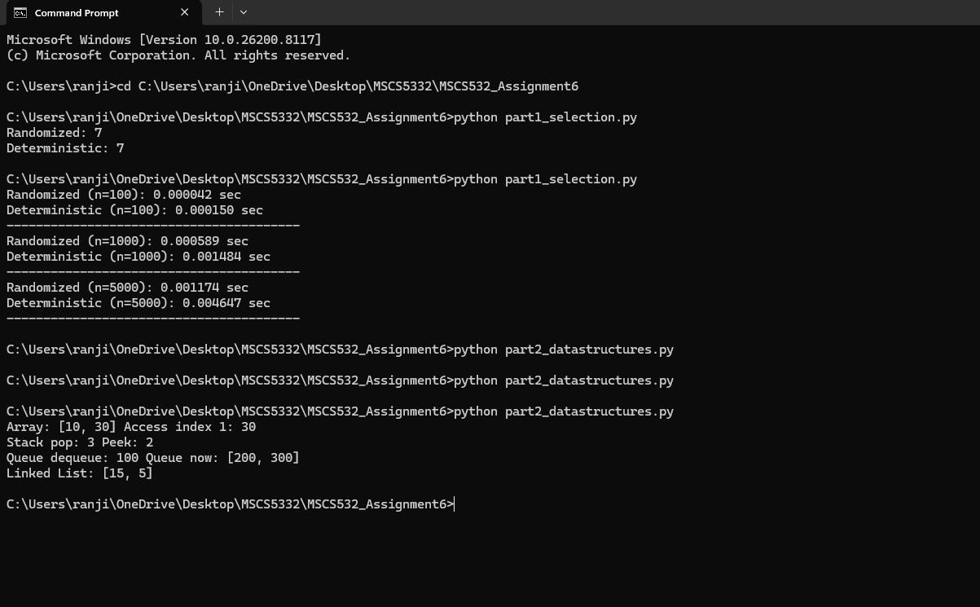
Conclusion
This assignment provided a comprehensive understanding of both selection algorithms and data structures. The comparison between randomized and deterministic approaches demonstrated the balance between theoretical guarantees and practical efficiency. While the deterministic algorithm offers reliability, the randomized approach performs better in most real-world scenarios.
Similarly, implementing data structures reinforced the importance of selecting the right structure based on the problem requirements. Each structure has its own strengths and limitations, and understanding these differences is critical for effective system design.
Overall, this assignment emphasizes that efficient problem-solving requires both strong theoretical knowledge and practical implementation skills. By combining these aspects, developers can build systems that are both efficient and scalable.

